1 RANSAC
  - Fitting a Line
- To compute a line, we need to fit the equation y = mx+b, where mmm is the slope and b is the y-intercept. To uniquely determine a line, we need two points. This is because a line in 2D space can be fully described with two points, and from these points, we can calculate the slope and intercept.
Answer: 2 points
- The likelihood of obtaining a good model depends on sampling inliers (non-outliers). If the outlier ratio is 0.1, it means 90% of the data points are inliers.
The probability that a single point is an inlier is 1−outlier ratio=0.9. Since we need two inliers to compute a good model, the probability that both points are inliers is:
P(both points are inliers)=0.9×0.9=0.81
Thus, the probability that the putative model fails (i.e., at least one point is an outlier) is:
P(failure)=1−P(success)=1−0.81=0.19
Answer: The probability of failure is 0.19 (19%)

- The probability of failure for one trial is 0.19, as calculated in the previous question. The probability of failure across N trials is (0.19)^N.
We want the probability of at least one success to be 95%, which means the probability of all trials failing must be less than 5%. The probability of all trials failing is 0.19^N, and we want this to be less than 0.05:
(0.19)^N < 0.05

Taking the logarithm of both sides:
Nln(0.19) < ln(0.05)

Solving for N:
N > ln(0.05) / ln(0.19) -> -2.995 / -1.6607 = 1.8

Answer : Since N must be an integer, 2 trials are needed

- It has 2 rows and 2 columns, so there are 4 elements in the matrix. Since each element can vary independently, the matrix M has 4 degrees of freedom.
Each pair of corresponding 2D points provides 2 equations (one for each dimension, x and y), so we need enough equations to uniquely solve for the 4 unknowns. Therefore, 2 pairs of corresponding points (which give 4 equations) are needed.
Answer:
  - Degrees of freedom: 4
  - Samples required: 2 pairs of corresponding points
- For each point (x_i, y_i) we have:
Mx_i = y_i
Here, M is 2x2 matrix, so we can flatten the matrix M into a vector m E R^4. To do this, we vectorize the equation Mx_i=y_i​.
The matrix A will have rows based on the input data x_i​, so it is structured as:
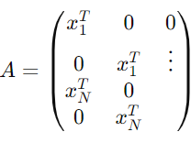
where each block corresponds to placing the components of x_i into the right locations for solving the least squares.
- S = array([[ 2.04098127, -3.0696843 ], [-1.01644528, 0.94335775]]),
t = array([-1.87154926, -3.05145812]))
- 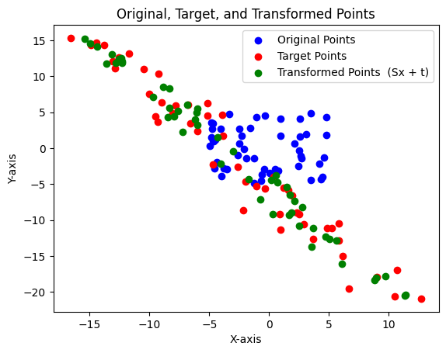

- We have the matrix S, which applies a linear transformation (scaling, rotation, or shearing) to the original points x.
- The vector t applies a translation (shifting) after the linear transformation.
- So, the transformation y=Sx+t first transforms the points using the matrix S and then shifts them using the translation t.
The fitting result is good by comparing the transformed points to the target points visually.
- Case 0 Homography Matrix H:
[[ 1.00555949e+00 1.61370672e-03 -1.35143989e-01]
[ 2.56045861e-03 6.22536404e-01 -7.35872070e-01]
[ 4.51704286e-05 3.59823762e-05 1.00000000e+00]]

Case 1 Homography Matrix H:
[[ 6.20394776e-01 1.50050345e-03 -6.60977645e-01]
[ 4.62565656e-05 1.00232229e+00 -4.06369835e-02]
[ 3.66035139e-07 2.25931463e-05 1.00000000e+00]]

Case 2 Homography Matrix H:
[[ 6.46216419e-01 1.01850154e-02 -1.45233663e+00]
[ 1.39156925e-02 6.46332905e-01 -1.60285342e+00]
[ 3.11050183e-04 2.76954685e-04 1.00000000e+00]]

Case 3 Homography Matrix H:
[[ 3.92727662e-14 1.00000000e+00 -4.01982298e-13]
[ 1.00000000e+00 6.17269379e-16 -1.05152358e-13]
[ 0.00000000e+00 -9.61481343e-17 1.00000000e+00]]

Case 4 Homography Matrix H:
[[-1.00000000e+00 6.59994092e-14 7.60000000e+01]
[-1.84203522e-13 -1.00000000e+00 1.01000000e+02]
[-4.53655995e-15 4.64620490e-15 1.00000000e+00]]

Case 5 Homography Matrix H:
[[ 4.01387046e-01 6.36777993e-01 -1.79445757e+00]
[ 6.40534201e-01 3.96745666e-01 -1.76059696e+00]
[ 2.21034153e-04 1.39932850e-04 1.00000000e+00]]

Case 6 Homography Matrix H:
[[ 7.70056604e-01 4.54255201e-02 -6.34808816e-02]
[-7.87253712e-02 8.63813194e-01 5.49671671e+00]
[-3.05270237e-04 -6.37121535e-05 1.00000000e+00]]

Case 7 Homography Matrix H:
[[ 8.41165566e-01 -4.86333708e-02 4.30457199e+00]
[-4.77384685e-02 9.86999947e-01 3.56055033e+00]
[-4.55556648e-04 1.08171485e-04 1.00000000e+00]]

- 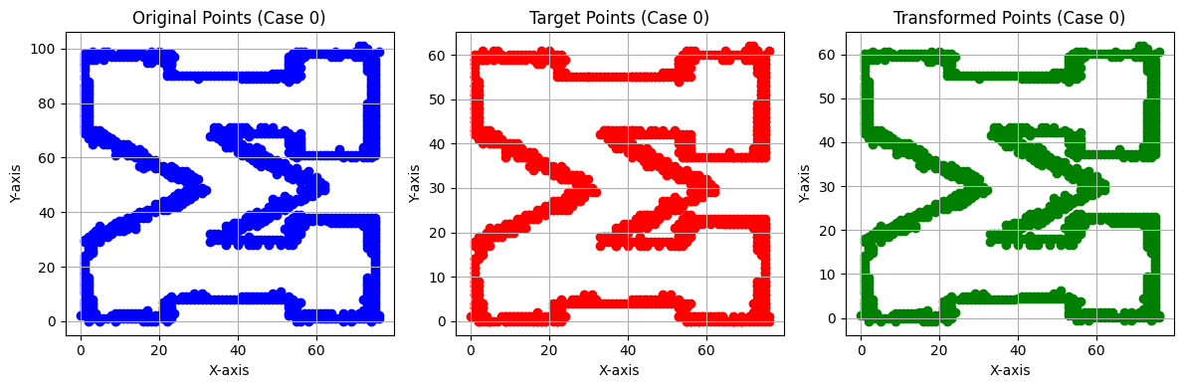
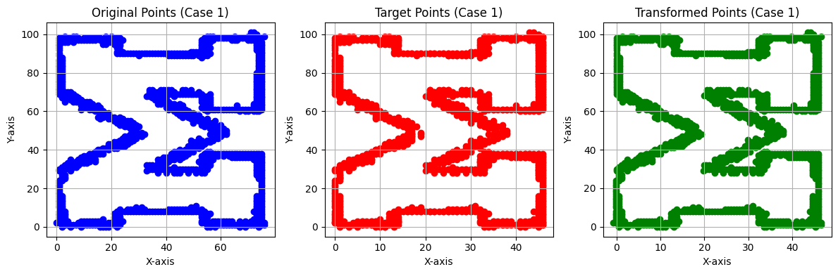
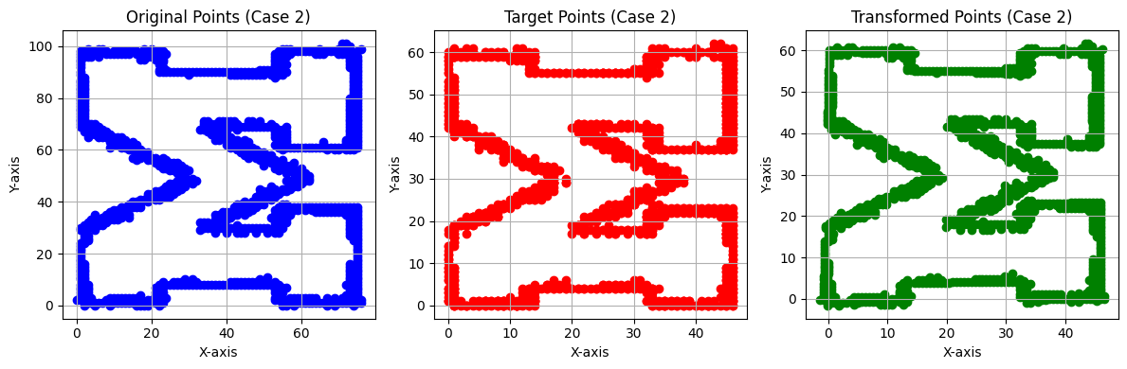
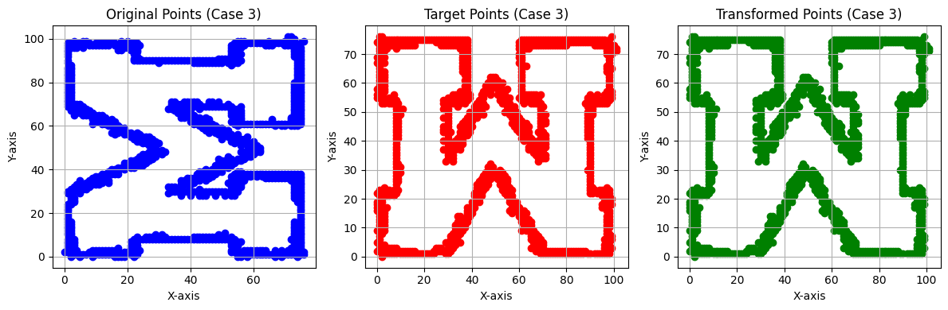
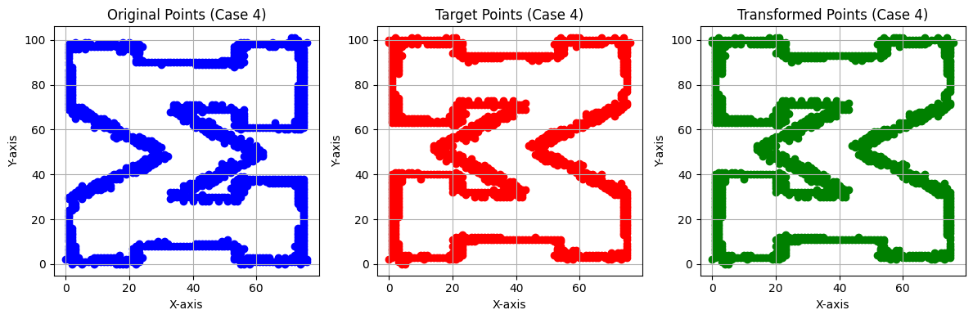
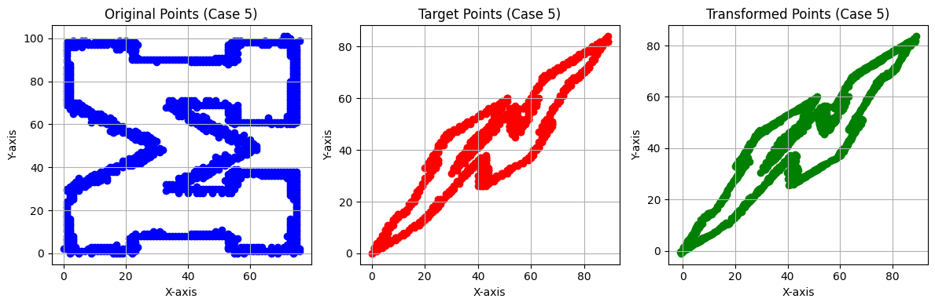
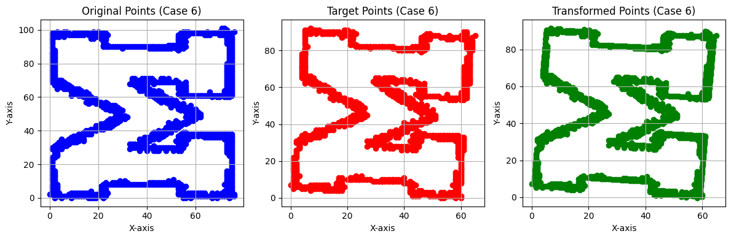
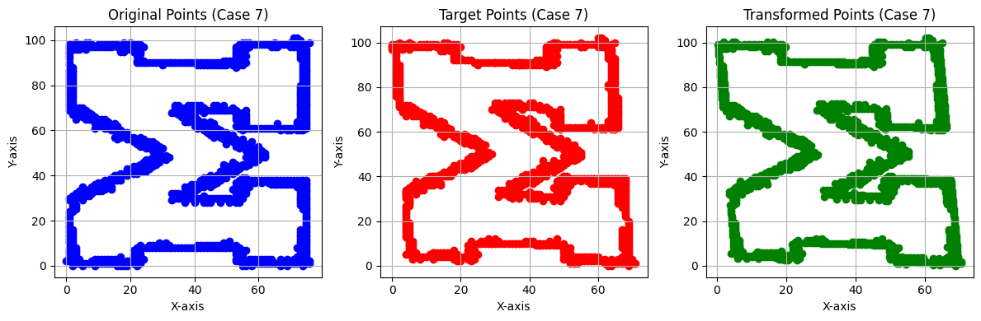
- The transformations make sense based on your visualizations, and H provides a good fit for the points in each case.

- Image Snitching
- 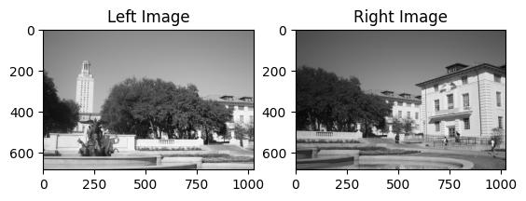
- 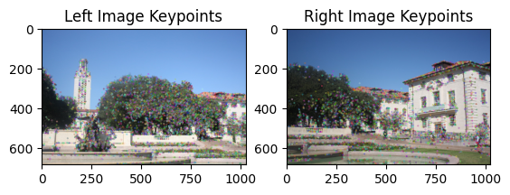
- Pairwise distances computed using Euclidean distance [[546.65344238 619.24871826 583.60516357 ... 522.36865234 598.44128418
517.43499756]
[645.28363037 684.09210205 648.66943359 ... 646.30950928 591.61724854
534.97290039]
[603.35150146 594.21710205 537.31555176 ... 567.46276855 527.1574707
581.91064453]
...
[609.45306396 608.62139893 612.79852295 ... 538.637146 631.91217041
572.35650635]
[492.00204468 414.45263672 521.03839111 ... 507.81787109 613.36450195
600.34741211]
[520.31719971 590.38208008 475.63537598 ... 515.29119873 549.85998535, 571.89074707]]

We chose to compute Euclidean distance between the descriptors of the two images for matching. Here’s why:
• Euclidean distance is a standard and straightforward way to measure the similarity between two descriptors, particularly when using descriptors like SIFT, which capture local gradients.
• Invariant to scaling: Normalizing the descriptors (making them zero-mean and unit-variance) before computing Euclidean distance ensures that different scale ranges of descriptor values are handled effectively.
• Comparison of vectors: Since descriptors like SIFT are feature vectors, computing the Euclidean distance between them directly measures how "far apart" two feature points are in a multidimensional space, which works well for matching.

Other alternatives considered:
- Normalized Cross-Correlation: While cross-correlation is useful for comparing patterns or signals, we opted for Euclidean distance due to its straightforward interpretation in feature matching.

- We used the nearest-neighbor ratio test to select putative matches based on the pairwise descriptor distances. Here's a breakdown of the choice:

Why Nearest-Neighbor Ratio Test:
- Robust to incorrect matches: The nearest-neighbor ratio test helps filter out bad matches by comparing the closest match with the second-closest match. This avoids picking feature points that might have equally likely alternatives, thereby reducing false positives.
- Reduces ambiguity: The ratio test ensures that we only select matches where the nearest descriptor is significantly better than the second-nearest one. If the nearest and second-nearest descriptors are too similar, it's likely that the match is ambiguous, and it's rejected.
Specifically, we chose the ratio threshold to be 0.75, meaning we accept a match if the distance to the nearest neighbor is less than 75% of the distance to the second-nearest neighbor.

Other Considerations:
- Distance Threshold: Instead of setting a fixed distance threshold (e.g., accepting all matches below a certain distance), we found the ratio test more flexible because it adapts to the variability in feature descriptors across different image regions.
- Top N Matches: Selecting the top N descriptor pairs based on distance was considered, but it doesn't take into account the distribution of distances, which may lead to selecting weak matches. The ratio test avoids this issue by focusing on the relative difference between the best and second-best matches.

- Number of inliers: 1068
Average residual for inliers: 1.4648
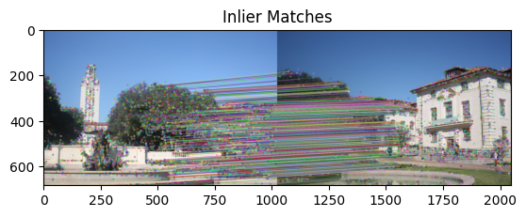
- 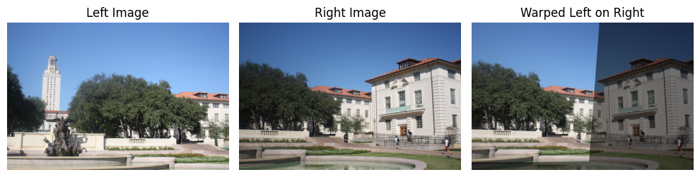
- 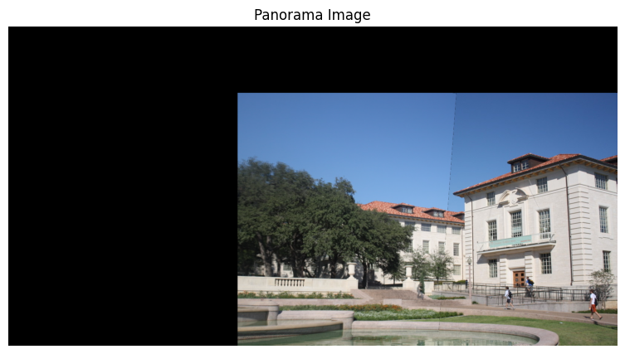
- Detected keypoints:
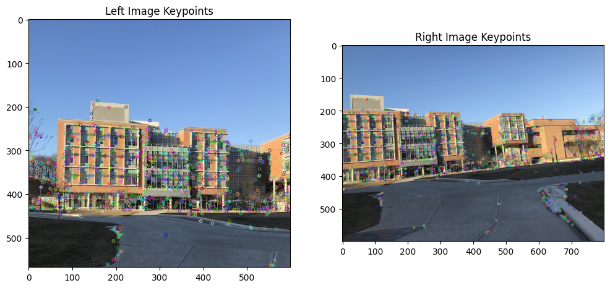
Matches
putative matches: [(112, 1108), (122, 92), (125, 3), (127, 5), (155, 139), (159, 44), (165, 45), (167, 41), (178, 72), (180, 862), (182, 81), (185, 2), (192, 79), (193, 11), (194, 3), (195, 3), (199, 200), (201, 96), (202, 17), (203, 18), (206, 22), (207, 37), (209, 39), (210, 110), (211, 31), (213, 29), (214, 30), (216, 44), (219, 243), (220, 244), (223, 41), (224, 69), (225, 64), (228, 67), (229, 45), (230, 46), (231, 68), (237, 62), (241, 71), (244, 65), (246, 66), (247, 48), (248, 59), (251, 97), (252, 99), (253, 171), (256, 84), (259, 84), (261, 79), (262, 93), (266, 92), (271, 200), (272, 82), (273, 112), (274, 105), (275, 96), (277, 106), (278, 102), (279, 100), (280, 119), (281, 22), (282, 23), (284, 131), (287, 138), (288, 110), (292, 128), (293, 30), (294, 147), (296, 142), (298, 142), (303, 146), (304, 45), (305, 145), (306, 157), (309, 178), (311, 71), (312, 156), (313, 190), (317, 191), (320, 199), (322, 84), (324, 176), (325, 84), (326, 172), (327, 206), (328, 207), (329, 187), (331, 203), (332, 200), (333, 212), (334, 200), (335, 208), (336, 195), (337, 211), (338, 106), (345, 234), (346, 202), (347, 224), (348, 232), (349, 226), (350, 230), (351, 201), (355, 42), (357, 219), (363, 238), (364, 217), (365, 251), (366, 251), (368, 233), (369, 250), (371, 142), (372, 249), (373, 222), (376, 243), (377, 244), (379, 261), (381, 270), (382, 271), (383, 242), (385, 45), (388, 259), (389, 277), (390, 254), (392, 285), (393, 286), (394, 260), (396, 253), (397, 288), (398, 289), (399, 236), (400, 241), (403, 278), (404, 281), (406, 62), (408, 71), (414, 268), (415, 276), (421, 252), (426, 301), (431, 304), (437, 306), (438, 315), (439, 311), (440, 273), (441, 296), (443, 328), (444, 308), (446, 334), (447, 326), (448, 327), (449, 321), (451, 342), (453, 307), (454, 336), (455, 338), (456, 345), (459, 320), (460, 323), (461, 335), (465, 355), (466, 351), (468, 329), (471, 344), (472, 339), (473, 358), (474, 356), (477, 340), (481, 337), (484, 361), (487, 370), (489, 368), (492, 367), (494, 362), (495, 360), (496, 357), (498, 382), (499, 380), (501, 389), (504, 390), (505, 391), (507, 397), (511, 373), (512, 407), (513, 405), (514, 403), (515, 400), (519, 393), (521, 419), (522, 416), (523, 414), (524, 387), (525, 406), (526, 392), (527, 398), (528, 388), (529, 429), (530, 430), (531, 411), (533, 433), (534, 431), (536, 399), (537, 399), (540, 410), (541, 412), (542, 439), (543, 440), (545, 428), (546, 437), (547, 426), (549, 420), (550, 418), (551, 417), (552, 436), (553, 425), (557, 446), (559, 445), (562, 441), (563, 434), (564, 435), (566, 443), (567, 438), (568, 444), (576, 574), (577, 575), (579, 459), (580, 460), (582, 453), (583, 442), (584, 464), (586, 458), (587, 461), (588, 476), (590, 447), (592, 454), (594, 468), (595, 469), (596, 463), (597, 474), (598, 475), (602, 462), (603, 466), (606, 527), (607, 528), (608, 477), (609, 478), (614, 484), (615, 490), (620, 550), (621, 551), (622, 553), (623, 510), (625, 512), (626, 513), (628, 452), (631, 503), (632, 506), (633, 517), (634, 515), (638, 516), (642, 576), (644, 526), (645, 525), (646, 496), (647, 523), (650, 497), (651, 498), (652, 534), (653, 501), (655, 532), (656, 504), (659, 541), (660, 539), (661, 452), (662, 543), (664, 536), (665, 527), (668, 560), (669, 556), (671, 522), (675, 611), (679, 569), (680, 570), (681, 569), (682, 570), (683, 558), (685, 533), (686, 561), (688, 548), (689, 637), (690, 549), (691, 550), (692, 551), (695, 553), (696, 571), (697, 591), (698, 452), (702, 578), (708, 611), (710, 594), (711, 584), (712, 585), (713, 584), (714, 585), (717, 595), (718, 583), (720, 598), (721, 572), (722, 583), (723, 514), (725, 636), (728, 551), (729, 607), (730, 571), (731, 623), (732, 587), (733, 588), (734, 589), (735, 610), (737, 452), (739, 527), (740, 528), (742, 609), (743, 906), (744, 907), (745, 620), (746, 625), (749, 629), (750, 611), (751, 599), (752, 632), (753, 633), (754, 622), (756, 618), (757, 619), (758, 645), (759, 635), (760, 636), (761, 637), (762, 638), (763, 550), (764, 551), (765, 612), (767, 553), (771, 630), (772, 452), (774, 647), (775, 640), (776, 641), (777, 661), (778, 670), (780, 651), (782, 662), (787, 678), (789, 664), (791, 663), (792, 676), (793, 673), (794, 659), (795, 656), (798, 673), (799, 665), (800, 666), (801, 667), (802, 685), (804, 691), (806, 682), (807, 671), (808, 693), (812, 690), (813, 684), (814, 672), (815, 674), (821, 698), (822, 686), (823, 689), (824, 688), (825, 698), (826, 692), (827, 681), (830, 704), (831, 705), (832, 675), (833, 713), (836, 702), (837, 703), (843, 687), (844, 717), (845, 699), (847, 723), (848, 764), (851, 716), (852, 712), (854, 709), (855, 741), (856, 742), (858, 744), (859, 737), (860, 736), (861, 730), (865, 724), (866, 721), (868, 720), (869, 719), (872, 727), (873, 739), (874, 740), (877, 728), (878, 732), (879, 733), (880, 732), (881, 733), (887, 800), (888, 729), (890, 760), (891, 750), (892, 759), (893, 750), (896, 756), (897, 738), (900, 745), (901, 734), (902, 735), (905, 747), (906, 765), (907, 765), (908, 751), (909, 784), (910, 780), (911, 103), (912, 762), (913, 769), (915, 777), (916, 778), (917, 779), (919, 794), (920, 764), (921, 763), (922, 801), (923, 802), (924, 776), (925, 771), (926, 770), (928, 775), (934, 792), (937, 767), (938, 768), (939, 790), (942, 804), (943, 788), (944, 789), (948, 796), (949, 809), (950, 800), (952, 807), (953, 828), (954, 829), (956, 797), (957, 830), (958, 803), (959, 827), (961, 816), (965, 816), (970, 805), (971, 813), (972, 806), (973, 842), (974, 822), (976, 833), (977, 834), (978, 834), (980, 747), (981, 758), (982, 854), (986, 839), (988, 858), (989, 844), (990, 845), (991, 831), (992, 832), (994, 864), (995, 846), (996, 838), (1000, 843), (1001, 852), (1002, 853), (1003, 837), (1004, 835), (1005, 836), (1006, 882), (1007, 883), (1008, 888), (1011, 865), (1012, 867), (1013, 873), (1015, 857), (1016, 859), (1017, 873), (1018, 850), (1019, 847), (1021, 890), (1025, 866), (1026, 862), (1028, 889), (1029, 896), (1030, 893), (1033, 894), (1034, 891), (1035, 892), (1038, 92), (1044, 870), (1048, 868), (1053, 895), (1054, 902), (1056, 875), (1058, 900), (1059, 901), (1061, 904), (1062, 899), (1065, 914), (1068, 915), (1071, 928), (1073, 924), (1077, 919), (1078, 927), (1081, 918), (1084, 928), (1085, 929), (1087, 930), (1088, 940), (1091, 942), (1095, 945), (1097, 949), (1099, 934), (1104, 954), (1109, 955), (1115, 960), (1117, 951), (1119, 961), (1124, 967), (1125, 968), (1129, 969), (1137, 959), (1138, 973), (1139, 964), (1140, 965), (1142, 964), (1143, 965), (1144, 974), (1145, 971), (1149, 975), (1156, 976), (1157, 983), (1158, 980), (1160, 986), (1161, 987), (1164, 984), (1166, 989), (1167, 990), (1171, 978), (1173, 992), (1180, 993), (1182, 1314), (1184, 988), (1185, 1002), (1186, 1000), (1187, 997), (1192, 998), (1197, 1004), (1205, 1019), (1206, 1021), (1207, 1013), (1208, 1009), (1212, 1007), (1221, 1020), (1223, 1034), (1224, 1025), (1227, 1041), (1228, 1038), (1231, 1047), (1233, 1058), (1234, 1057), (1237, 1048), (1238, 1049), (1245, 1052)]
Inliers
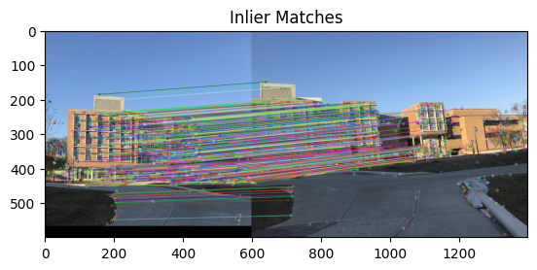
Snitch image
